|  |  |  |
| --- | --- | --- |
| **University of Petra** | ***شعار جامعة البترا5 -*** | ***C:\Documents and Settings\jsaqqa\Local Settings\Temporary Internet Files\Content.Outlook\ZIA6H205\شعار جامعة البترا - عشرون عاما 1.jpg*** |
| **Faculty of Information Technology** | **كلية تكنولوجيا المعلومات** |

Green Points

**Prepared by:**

Ayham Elmasri | 201620753

Suzan Alabsi | 201610158

Roa’a Ghali | 201610678

**Supervised by:**

Dr. Ahamd Shubita

**Date:**

2019/2020

Second Semester

# ACKNOWLEDGMENT

We sincerely would like to thank our parents first and foremost for their continuous support and guidance for helping us reach this turning point in our lives, and we will be forever grateful for their unconditional love and sacrifices towards us. We would also like to thank our supervisor Dr. Ahmad Shubita for his help and guidance throughout the semester for our graduation project. We would like to thank anyone who stood by our idea and believed in us and helped us emotionally throughout this journey.

# ABSTRACT

The problem of environmental pollution around the world is still very high and poses a great threat to the whole earth, especially pollution due to plastic materials or materials made of plastic or with some percentages of plastic and the time it takes for plastics to decompose naturally or through expensive industrial machines Relatively expensive and recycling plastic into materials is easy to use raw materials again, so we in this project are trying to help institutions and individuals reduce the use of everything made of plastic and replace it with materials made of materials that can be analyzed and easily recycled and we motivate individuals to change their perceptions of the materials they use Of plastic and its great negative impact on us as individuals, our societies or the earth in general by giving points to every material that was thrown in the garbage and is recyclable through application, and we end up seeking to build a generation, society and healthy lands free of materials that are difficult to analyze or easily recycle This is to facilitate life more, accelerate operations and build a green community.

Table of Contents

ACKNOWLEDGMENT ii

ABSTRACT iii

Table of Contents iv

Table of Figuers viii

Table of Tables x

Appendix A - Firgures x

1. Chapter One: Project Initiating 1

1.1 Introduction 2

1.1.1 Problem Definition 2

1.1.2 project objectives 3

1.2 Current & Existing Systems 3

1.2.1 Current System 3

1.2.2 Existing System 4

1.3 Literature Review 5

1.3.1 Introduction 5

1.3.2 The importance of Recycling 6

1.3.2.1 Environmental Benefits 6

1.3.2.2 Economic Benefits 6

1.3.3 Recycling Around the World 7

1.3.4 Recycling Creates Jobs 9

1.3.5 The Impact of Recycling on Higher Education 10

1.3.6 Recent technologies 11

1.3.6.1 Dart Programming Language & Flutter Framework 11

1.3.6.2 (SQL Server) 11

1.3.6.3 Arduino 12

1.3.6.4 Arduino Uno 12

1.3.6.5 Arduino Sensors 12

1.3.7 Conclusion 14

1.4 Stakeholder List 15

1.5 Proposed scope & Process model 16

1.5.1 proposed scope 16

1.5.2 Process model 16

1.5.3 Scope excluded and project constraints 16

2. Chapter Two: Planning and Requirements 18

2.1 Planning 19

2.1.1 Scope Initiation (WBS) 19

2.1.2 Gantt Chart 22

2.1.3 Resource Sheet 24

2.1.4 System Development Requirement 25

2.1.5 Cost Estimating & Budgeting 26

2.1.6 Risk List 27

2.2 Requirements 27

2.2.1 Information Gathering 27

2.2.2 Initial functional requirements 30

2.2.3 Initial non-functional requirements 30

2.3 Use cases 31

2.3.1 Detect user Account 31

2.3.2 Receive data from sensors 32

2.3.3 Distinguish and Separate Material 33

2.3.4 Calculate points. 34

2.3.5 Update the points. 35

2.3.6 Redeem rewards. 36

2.3.7 Users edit their profile. 37

2.3.8 Log in 38

2.3.9 Users view friends points. 39

2.3.10 Users add friends. 40

2.3.11 Users view leaderships 41

2.4 Domain Diagram 42

3. Chapter Three: Project Analysis and Design 43

3.1 Use Case Diagram 44

3.2 Activity Diagrams 45

3.2.1 Detect the users account. 45

3.2.2 Receive data from sensors. 46

3.2.3 Distinguish and separate the material. 47

3.2.4 Calculate the points. 48

3.2.5 Update the points. 49

3.2.6 Redeem rewards. 50

3.2.7 Users edit their profile. 51

3.2.8 Login. 52

3.2.9 View friends points. 53

3.2.10 Add friends. 54

3.3 Sequence Diagrams 55

3.3.1 Detect the users account. 55

3.3.2 Receive data from sensors. 56

3.3.3 Distinguish and separate the material. 57

3.3.4 Calculate the points. 58

3.3.5 Update the points. 59

3.3.6 Redeem rewards. 60

3.3.7 Users edit their profile. 61

3.3.8 Login. 62

3.3.9 View friends points. 63

3.3.10 Add friends. 64

3.4 Design Class Diagram 65

3.5 State Diagrams 66

3.5.1 Points 66

3.5.2 Material 67

3.5.3 Items 68

3.5.4 Login 68

3.6 Component Diagram 69

3.7 Deployment Diagram 70

3.8 Input Screens 71

3.9 Output Screens 72

4. Chapter Four: Implementation and Testing 74

4.1 Database Mapping (Schema Diagram) 75

4.2 Tables Description 75

4.2.1 Material Table 75

4.2.2 History table 76

4.2.3 Shop Table 76

4.2.4 Items Table 76

4.2.5 Users Table 77

4.2.6 Friends Table 77

4.3 Architecture/Technology Description 78

4.3.1 MVC (Model, View, Controller) 78

4.4 Algorithm for major functions 79

4.4.1 Login Function 79

4.4.2 Redeem Function 79

4.4.3 Calculate Function 80

4.5 Implementation of main Functions 81

4.5.1 Calculate Function 81

4.5.2 Redeem Function 83

4.6 Functional test cases 86

4.6.1 Login test cases 86

4.6.2 Redeem test cases 87

4.6.3 Calculate test cases 87

4.7 User Manual 88

5. Chapter Five: Conclusion and Future Improvements 92

5.1 Conclusion 93

5.2 Future Improvements 93

References 94

Appendixes 97

# Table of Figuers

[Figure 1University of Petra 3](https://uopstdedu-my.sharepoint.com/personal/201620753_uopstd_edu_jo/Documents/Graduation%20Project/Final%20Documintaion.docx#_Toc42280660)

[Figure 2 Green Bean 4](https://uopstdedu-my.sharepoint.com/personal/201620753_uopstd_edu_jo/Documents/Graduation%20Project/Final%20Documintaion.docx#_Toc42280661)

[Figure 3 Green Spot 4](https://uopstdedu-my.sharepoint.com/personal/201620753_uopstd_edu_jo/Documents/Graduation%20Project/Final%20Documintaion.docx#_Toc42280662)

[Figure 4 Gantt Chart - 1 22](https://uopstdedu-my.sharepoint.com/personal/201620753_uopstd_edu_jo/Documents/Graduation%20Project/Final%20Documintaion.docx#_Toc42280663)

[Figure 5 Gantt Chart - 2 23](https://uopstdedu-my.sharepoint.com/personal/201620753_uopstd_edu_jo/Documents/Graduation%20Project/Final%20Documintaion.docx#_Toc42280664)

[Figure 6 Gantt Chart - 3 23](https://uopstdedu-my.sharepoint.com/personal/201620753_uopstd_edu_jo/Documents/Graduation%20Project/Final%20Documintaion.docx#_Toc42280665)

[Figure 7 Gantt Chart - 4 24](https://uopstdedu-my.sharepoint.com/personal/201620753_uopstd_edu_jo/Documents/Graduation%20Project/Final%20Documintaion.docx#_Toc42280666)

[Figure 8 Cost OverView 26](https://uopstdedu-my.sharepoint.com/personal/201620753_uopstd_edu_jo/Documents/Graduation%20Project/Final%20Documintaion.docx#_Toc42280667)

[Figure 9 Domain Diagram 42](https://uopstdedu-my.sharepoint.com/personal/201620753_uopstd_edu_jo/Documents/Graduation%20Project/Final%20Documintaion.docx#_Toc42280668)

Figure 10 Use Case Diagram 44

Figure 11 Detect User Account Activity Diagram 45

Figure 12 Receive Data from sensors Activity Diagram 46

Figure 13 Distinguish and separate material Activity Diagram 47

Figure 14 Calculate points Activity Diagram 48

Figure 15 Update Points Activity Diagram 49

Figure 16 Redeem Reward Activity Diagram 50

Figure 17 User edit profile Activity Diagram 51

Figure 18 Login Activity Diagram 52

Figure 19 View friends points Activity Diagram 53

Figure 20 Add friends Activity Diagram 54

Figure 21 Detect users account Sequence Diagram 55

Figure 22 Receive data from sensors Sequence Diagram 56

Figure 23 Distinguish and separate material Sequence Diagram 57

Figure 24 Calculate points Sequence Diagram 58

Figure 25 Update points Sequence Diagram 59

Figure 26 Redeem points Sequence Diagram 60

Figure 27 User edit profile Sequence Diagram 61

Figure 28 Login Sequence Diagram 62

Figure 29 View friends points Sequence Diagram 63

Figure 30 Add friend Sequence Diagram 64

Figure 31 Design class Diagram 65

Figure 32 Points Sate Diagram 66

Figure 33 Material State Diagram 67

Figure 34 Items State Diagram 68

Figure 35 Login State Diagram 68

Figure 36 Component Diagram 69

Figure 37 Deployment Diagram 70

[Figure 40 Scan Screen 71](https://uopstdedu-my.sharepoint.com/personal/201620753_uopstd_edu_jo/Documents/Graduation%20Project/Final%20Documintaion.docx#_Toc42280697)

[Figure 38 Login Screen 71](https://uopstdedu-my.sharepoint.com/personal/201620753_uopstd_edu_jo/Documents/Graduation%20Project/Final%20Documintaion.docx#_Toc42280698)

[Figure 39 Add friend Screen 71](https://uopstdedu-my.sharepoint.com/personal/201620753_uopstd_edu_jo/Documents/Graduation%20Project/Final%20Documintaion.docx#_Toc42280699)

[Figure 42 Friend Screen 72](https://uopstdedu-my.sharepoint.com/personal/201620753_uopstd_edu_jo/Documents/Graduation%20Project/Final%20Documintaion.docx#_Toc42280700)

[Figure 41 Friends List Screen 72](https://uopstdedu-my.sharepoint.com/personal/201620753_uopstd_edu_jo/Documents/Graduation%20Project/Final%20Documintaion.docx#_Toc42280701)

[Figure 43 Home Screen 72](https://uopstdedu-my.sharepoint.com/personal/201620753_uopstd_edu_jo/Documents/Graduation%20Project/Final%20Documintaion.docx#_Toc42280702)

[Figure 44 Leadership Screen 72](https://uopstdedu-my.sharepoint.com/personal/201620753_uopstd_edu_jo/Documents/Graduation%20Project/Final%20Documintaion.docx#_Toc42280703)

[Figure 46 Items Screen 73](https://uopstdedu-my.sharepoint.com/personal/201620753_uopstd_edu_jo/Documents/Graduation%20Project/Final%20Documintaion.docx#_Toc42280704)

[Figure 47 Shops Screen 73](https://uopstdedu-my.sharepoint.com/personal/201620753_uopstd_edu_jo/Documents/Graduation%20Project/Final%20Documintaion.docx#_Toc42280705)

[Figure 45 Popups 73](https://uopstdedu-my.sharepoint.com/personal/201620753_uopstd_edu_jo/Documents/Graduation%20Project/Final%20Documintaion.docx#_Toc42280706)

Figure 48 Database Schema Diagram 75

Figure 49 Material Table 75

Figure 50 Material Table 76

Figure 51 Shop Table 76

Figure 52Items Table 76

Figure 53 Users Table 77

Figure 54 Friends Table 77

Figure 55 MVC Architecture 78

[Figure 56 Calculate Class Implementation Code 81](https://uopstdedu-my.sharepoint.com/personal/201620753_uopstd_edu_jo/Documents/Graduation%20Project/Final%20Documintaion.docx#_Toc42280715)

[Figure 57 getMaterial() method implementation 81](https://uopstdedu-my.sharepoint.com/personal/201620753_uopstd_edu_jo/Documents/Graduation%20Project/Final%20Documintaion.docx#_Toc42280716)

[Figure 58 get_material.php implementation 82](https://uopstdedu-my.sharepoint.com/personal/201620753_uopstd_edu_jo/Documents/Graduation%20Project/Final%20Documintaion.docx#_Toc42280717)

[Figure 59 Material class implementation 82](https://uopstdedu-my.sharepoint.com/personal/201620753_uopstd_edu_jo/Documents/Graduation%20Project/Final%20Documintaion.docx#_Toc42280718)

[Figure 60 implementation of points calculation 83](https://uopstdedu-my.sharepoint.com/personal/201620753_uopstd_edu_jo/Documents/Graduation%20Project/Final%20Documintaion.docx#_Toc42280719)

Figure 61 ShopScreen implementation Code 83

Figure 62 getShops Method implementation 84

Figure 63 get_shops.php implementation 84

Figure 64 ItemsScreen implementation Code 85

Figure 65 getitems Method Implementation 85

Figure 66 get_items.php implementation 86

Figure 67 Login User Manual 88

Figure 68 Home Screen User Manual 88

Figure 69 Friends Screen User Manual 89

Figure 70 Shops Screen User Manual 89

Figure 71 Items Screen User Manual 90

Figure 72 Leader Ship Screen User Manual 90

Figure 73 Edit Profile User Manual 91

Figure 74 Scan Screen User Manual 91

# Table of Tables

Table 1 Stakeholders List 15

Table 2 Scope Initiation (WBS) 19

Table 3 Resource Sheet 24

Table 4 System Development Requirement 25

Table 5 Cost Estimation 26

Table 6 Detect User Account Use Case 31

Table 7 Receive data from sensors Use Case 32

Table 8 Distinguish and Separate Material Use Case 33

Table 9 Calculate points. 34

Table 10 Update the points Use case 35

Table 11 Redeem rewards Use Case 36

Table 12 Users edit their profile Use Case 37

Table 13 Login Use Case 38

Table 14 Users to view friends points Use Case 39

Table 15 Users add friends Use Case 40

Table 16 Users view leaderships Use Case. 41

Table 17 Login test Cases 86

Table 18 Redeem test Cases 87

Table 19 Calculate test Cases 87

# Appendix A - Firgures

Appendix A - Figure 1 Recycle Group 97

Appendix A - Figure 2 Recycle frequency Group 97

Appendix A - Figure 3 Recycling material Group 98

Appendix A - Figure 4 Why Recycling ? 98

Appendix A - Figure 5 Why not Recycling? 98

Appendix A - Figure 6 How Convenient? 99

Appendix A - Figure 7 Recommendation for easier recycling 99

Appendix A - Figure 8 Distance group 100

Appendix A - Figure 9 relativity to education and consuming recycled material Group 100

# Chapter One: Project Initiating

## Introduction

We are facing a very huge problem and it harms our planet and that problem is excessive waste and pollution. The application GreenPoints is an application for reducing the plastic consumption in the campus of universities. It aims to encourage college students to recycle cups, papers and any recyclable material consumed daily by college students, by using points.

### Problem Definition

Over 300 million tons of plastic is produced each year, with a scary amount of it being single use. More than eight million tons of plastic is dumped into the oceans each year. (Plastic Oceans, 2020)

In Universities alone over 50% of college students consume caffeinated beverages daily. Energy drinks are a top choice, but coffee is the most popular among them. As a study show that 78% of college freshman consume above the recommended amount of caffeine per day. (Kissam, 2019)

University campuses have a huge number of a wide range of age inside it. The majority people inside the campuses are students. Youths are the society future they will build the future of the societies. As a study shows that College students, are the largest and active group of online shoppers, are the key participants in the Internet era which will make them the most group of people that consumes packaging waste and waste in general. Although college students are the biggest group of people that consumes packaging waste (which is cardboard and papers). They are also the most group of people that want a greener and healthier environment. A study shows that 80.83% of college students says that there is too much waste and a recycling system should be established (Wenjing, 2019).

### project objectives

**Objective 1:** Reduce waste, pollution, trash in landfills and environmental impact.

**Objective 2:** Increase the culture of recycling among students (REDUSE, REUSE, RECYCLE).

**Objective 3:** Raise the personal and public awareness.

**Objective 4:** Save energy and valuable raw materials.

## Current & Existing Systems

### Current System

**University of Petra – Jordan**

Figure University of Petra

University of Petra is currently using a manual system of recycling materials. As a result of lack of awareness and limited culture on recycling in the university community, the recycle bins in the campus is poorly used by students.

Short comes:

* The lack motivation for the students to recycle.
* There is no points or reward system for the students.
* Inefficient recycle bins.
* Lack of attraction and awareness on recycling.

### Existing System

**GreenBean – Several countries**

Figure Green Bean

It’s a website that is integrated with TOMRA reverse vending machine (RVM). Greenbean makes it fun and easy for students to recycle their bottles and cans responsibly through TOMRA RVMs on campus. Every time a student inserts a bottle or can into a Greenbean RVM, he or she can enter an email address to link to a rewards account, accessible via the web. Students can save up points to earn rewards such as reusable grocery bags, gift cards and other prizes. Students can also choose to donate their points to local charities. In bottle deposit states, where used beverage containers are worth money, students can have the deposit cash transferred into a PayPal account. (BUCHANAN, 2015)

Short comes:

* Portability, it is not portable because they are just using a website for tracking rewards.

**GreenSpot - Jordan**

Figure Green Spot

A Green Spot is an ecological concept which describe a place where people care for the environment and taking positive actions towards it by practicing the recycling of their own solid waste as a daily habit, their clients whom cooperating with them in recycling waste paper, they sort their own waste and store the waste paper for them, and once their recycling bins are full the greenspot employees visit the clients to collect the paper and send it to paper recycling factory. (GreenSpot, 2019)

Short comes:

* The system doesn’t target Higher Education campuses.
* The client must sort the waste according to their type before handling it to the delivery person.

## Literature Review

### Introduction

Recycling is the process of breaking down and re-using materials that would otherwise be thrown away as trash. Many communities and businesses make it easy to recycle by placing labelled containers in the open for public use, or providing bins for home and business owners who have curbside pickup. (Rinkesh, 2020)

Recycling is the process of collecting and processing materials that would otherwise be thrown away as trash and turning them into new products. Recycling can benefit your community and the environment. (EPA, 2017)

Recycling involves: Separating materials; Collecting them; Re-manufacturing those materials into new products; Buying those new products and Using those new products.

There are numerous benefits to recycling, and with so many new technologies making even more materials recyclable, with everyone’s help we can clean up our Earth. Recycling not only benefits the environment but also have a positive effect on the economy. Recycling is reported throughout human history but has come a long way since the time of Plato when humans re-used broken tools and pottery when materials were scarce. Today, there is a multitude of benefits that come from recycling as well as tons of items that can be recycled.

(Rinkesh, 2020)

### The importance of Recycling

#### Environmental Benefits

By recycling people can prevent millions of tons of material from entering landfills saving space for garbage that cannot be re-purposed. Landfills not only pollute the environment but also hampers the beauty of the city.

The pollutants that are released into the air and water can be greatly reduced with an increase in recycling.

Greatly reduces the amount of energy used daily by not needing to produce new materials. In short, recycling reduces the greenhouse gas emissions into the atmosphere.

If for absolutely nothing else, recycling keeps litter overflow to a minimum keeping the Earth looking beautiful.

In terms of energy, a single light bulb can be powered for up to four hours with the energy saved from one recycled glass bottle.

Conserves the Earth’s natural resources like raw materials, minerals, trees, etc. (Rinkesh, 2020)

#### Economic Benefits

Properly run recycling programs cost the government, taxpayers, and business owners less money than waste programs.

Studies show that by continuing to increase positive recycling habits, the United States can create over one million jobs annually.

People can even make money by collecting approved materials to a nearby recycling facility that will pay for the product.

For everyone job created in the waste management industry recycling creates four. (Rinkesh, 2020)

### Recycling Around the World

**IN US,** Data on global waste management is hard to gather in a meaningful way because there are so many sources, journeys, and endpoints for waste.

The plastic bottle you put in a recycling container in your home in New York goes on a different journey than the plastic bottle you toss into the wrought-iron trash container on the sidewalk of Dallas. When scaled to account for entire countries, these differences make data collection challenging.

But the Organization for Economic Cooperation and Development (OECD) has made a valiant effort to track municipal waste management throughout its 35 member states. And the results are striking.

At the bottom of the list are Turkey and Chile, which each recycle an abysmal 1% of total waste, according to the report. They are also the only countries to have become worse at recycling since 2000, with 33% and 78% declines, respectively.

The US has an overall recycling rate of 35% and the average throughout the OECD is 34%. (Joe McCarthy, 2016)

**IN Turkey**, waste management is not a priority issue. Therefore, the vast majority of trash ends up in landfills. In Chile, unregulated dumping is common because the waste management system is spotty.

**IN Germany,** meanwhile Germany, leads the pack with a 65% recycling rate, which has risen 16% since 2000. Germany is so good at recycling for a couple of reasons. First, the country has gone to considerable lengths to standardize recycling containers throughout the country. There are color-coded containers all throughout the country that people adhere to. Second, Germans enjoy recycling and the sense of civic virtue it bestows. A culture of environmental sustainability reigns in the country. (Joe McCarthy, 2016)

**IN Poland,** in terms of countries making the most improvement, Poland is at the top of the list. It’s recycling an astounding 886% more of its waste than it was at the start of millennium. Estonia has increased its recycling by 600% in the same period, Ireland has increased by 261%, and the UK by 250%.

(Joe McCarthy, 2016)

In Addition: South Korea, Austria, Belgium, Slovenia, Sweden, and Switzerland have overall recycling rates above 50%.

Across the board, countries have gotten 42% better at recycling. That’s a good sign, because waste management will be of critical importance throughout the next century.

It’s estimated that the amount of waste generated by humans globally will more than triple from 1.3 billion tons today to 4 billion tons by 2100.

Bad waste management contaminates waterways and soil and causes climate change accelerating emissions. It harms animal and plant life, leads to deforestation, and spreads disease.

(Joe McCarthy, 2016)

**IN Jordan,** Jordan has wetness a large increase in the population during the past five decades as a result of population growth and forced migration, resulting in an increase in the volume of waste. These challenge urges the need for finding proper and easy ways of making the living is healthy! (Aljaradin, 2011)

Many of us don’t think twice about tossing out bottles, cans, and paper along with the rest of our trash, in fact, Jordan generates 2.2 million tons of municipal solid waste annually. (UNDP in Jordan, 2017)

the amount of solid household waste in Jordan is 1.4 million tons annually, while industrial waste reaches 165 thousand tons annually, and agricultural waste 1.6 million tons annually. The components of solid waste are divided into organic materials (62%), plastic (16%), paper and cardboard (11%), fabrics (4%), glass (2%), minerals (2%), garden waste (0.5%) and other materials such as ceramic, rubber and leather (khashashneh, 2002).

Al-Ghabawi is the only sanitary landfill in Jordan (out of the 3-4 landfills in Jordan) a very good step towards more sustainable waste management in Jordan.

In this Ghabawi landfill, there are nine cells for the burry of waste, as one layer of waste is buried first, followed by a layer of soil and so on and this way is sustainable.

In Jordan, we rely heavily on groundwater as a natural resource, the cells are constructed in a way where they do not affect precious groundwater.

Another great aspect of Al-Ghabawi landfill is that when the waste is pressed, Methane gas is produced, and now this is being extracted for electricity use. (Fawwaz, 2015).

### Recycling Creates Jobs

EPA released significant findings on the economic benefits of the recycling industry with an update to the national Recycling Economic Information (REI) Study in 2016. This study analyzes the numbers of jobs, wages and tax revenues attributed to recycling. The study found that in a single year, recycling and reuse activities in the United States accounted for:

• 757,000 jobs

• $36.6 billion in wages; and

• $6.7 billion in tax revenues.

This equates to 1.57 jobs, $76,000 in wages, and $14,101 in tax revenues for every 1,000 tons of materials recycled. . (EPA, 2017)

### The Impact of Recycling on Higher Education

University campuses have a huge number of a wide range of age inside it. The majority people inside the campuses are students. Youths are the society future they will build the future of the societies. Nowadays, university campuses are moving towards greener and sustainable campus. What are the ways that will help us having a greener environment? Targeting youths is the most effective way to increase the recycling culture in our society. As a study shows that College students, are the largest and active group of online shoppers, are the key participants in the Internet era which will make them the most group of people that consumes packaging waste and waste in general (Wenjing, 2019).

Although college students are the biggest group of people that consumes packaging waste (which is cardboard and papers). They are also the most group of people that want a greener and healthier environment. As a study shows that 80.83% of college students says that there is too much waste and a recycling system should be established (Wenjing, 2019).

### Recent technologies

#### **Dart Programming Language & Flutter Framework**

Flutter, a framework for Dart, is an open source UI Software development kit created by Google and is built on Dart programming language. It is used mainly for mobile applications and most recently on the web .The good thing about Flutter is that it is a one-base code that can be compiled and deployed to iOS and Android operating systems. By introducing Flutter, this can efficiently save a lot of time and cost for companies (such as cutting the cost of human resources) which specifically work on mobile application which some consist of two teams, one for iOS development and the other is for Android development. (Kevin, 2019)

Flutter has the hot load feature which if anything is changed in the code on the IDE (Integrated Development Environment), the change will be seen instantly on either the device that has been linked with the PC or the emulator that has been installed.

#### (SQL Server)

Microsoft SQL Server is a relational database management system (RDBMS) that supports a wide variety of transaction processing, business intelligence and analytics applications in corporate IT environments. Microsoft SQL Server is one of the three market-leading database technologies, along with Oracle Database and IBM's DB2, Microsoft also bundles a variety of data management, business intelligence (BI) and analytics tools with SQL Server. In addition to the R Services and now Machine Learning Services technology that first appeared in SQL Server 2016, the data analysis offerings include SQL Server Analysis Services, an analytical engine that processes data for use in BI and data visualization applications, and SQL Server Reporting Services, which supports the creation and delivery of BI reports.

(Rouse, 2006)

#### Arduino

Arduino is an open-source electronics platform based on easy-to-use hardware and software. Arduino boards are able to read inputs - light on a sensor, a finger on a button, or a Twitter message - and turn it into an output - activating a motor, turning on an LED, publishing something online. You can tell your board what to do by sending a set of instructions to the microcontroller on the board. To do so you use the Arduino programming language (based on Wiring), and the Arduino Software (IDE), based on Processing. (Arduino, 2020)

#### Arduino Uno

Is a microcontroller board developed by Arduino.cc which is an open-source electronics platform mainly based on AVR microcontroller Atmega328.First Arduino project was started in Interaction Design Institute Ivrea in 2003 by David Cuartielles and Massimo Banzi with the intention of providing a cheap and flexible way to students and professional for controlling a number of devices in the real world.The current version of Arduino Uno comes with USB interface, 6 analog input pins, 14 I/O digital ports that are used to connect with external electronic circuits. Out of 14 I/O ports, 6 pins can be used for PWM output.It allows the designers to control and sense the external electronic devices in the real world. (Aqeel, 2018)

#### Arduino Sensors

When an electronic hobbyists start designing any project, the main concern factor would be the compatibility issue between hardware and the available software IDEs. Invented around the 2000s, Arduino came as an answer for such issues. Arduino is the product of effort put forth by a group of Italian postgraduates and a lecturer at the interaction design institute in Ivrea. This microcontroller is named after the 11th-century Italian king Arduin of Ivrea. The crucial factor in the success of this microcontroller platform is its Open-Source nature. With the success of this project, later many new products were designed which are compatible with this platform such as Arduino sensor, Arduino comes with a microcontroller and a software IDE to upload the code into the hardware board. Seeing the popularity of Arduino among hobbyist many sensors which are compatible with Arduino were launched, there are various types of Arduino sensors available in the market. These sensors help Arduino to interact with the surroundings and for designing new applications, (Electronics Projects Focus, 2013)

IR Infrared Obstacle Avoidance sensor,This device emits and/or detects infrared radiation to sense a particular phase in the environment. Generally, thermal radiation is emitted by all the objects in the infrared spectrum. The infrared sensor detects this type of radiation which is not visible to human eye.

Advantages

· Easy for interfacing

· Readily available in market

Disadvantages

· Disturbed by noises in the surrounding such as radiations, ambient light etc. (eTechnophiles, 2018)

NFC sensor, The NFC sensor uses wireless communication with high frequency for data transferring among devices over a distance of 10 cm. This wireless communication makes our life more convenient and easier by conducting transactions & exchanging data. NFC sensor is better than Bluetooth due to its features like easy setup, needs less power, gives more security. (Electronics Projects Focus, 2013)

HX711 sensor, The SparkFun Load Cell Amplifier is a small breakout board for the HX711 IC that allows you to easily read load cells to measure weight. By connecting the amplifier to your microcontroller you will be able to read the changes in the resistance of the load cell, and with some calibration you’ll be able to get very accurate weight measurements. This can be handy for creating your own industrial scale, process control or simple presence detection. (SparkFun, 2017)

Many university campuses have moved towards a greener campus and implementing recycling culture. Harvard University, Brandeis University, Massachusetts Institute of Technology, Northeastern University, Merrimack College, Bentley University and University of Southern Indiana. These universities have adopted a recycling program called Greenbean. Greenbean is a program developed by Torma. Greenbean is using reverse vending machines (RVM). There program is aiming to help students track their recycling points and rewards. Usually the put the machines in places that have a high density of students or in the campus center to attract students and promote the recycling culture by giving them motives like prizes and other rewards (Gerlat, 2015).

### Conclusion

Considering all of the economic and environmental impacts, the choice on whether or not to recycle truly does depend on an organization's size and dedication to preserving the earth we live on. While, yes, it is true that recycling practices could be time consuming and mildly counter-productive, the savings alone ca justify that you are saving hundreds of trees from needless destruction. As some of the biggest producers of paper waste, huge organizations, such as companies and public institutions, really need to understand that, especially for them, it is no small amount of paper: The average web user prints 28 pages per day, so multiply that by the number of employees that have a desk with a computer with access to a printer, and there's a ball park figure for how much paper waste an institution generates on its own. Large institutions need to realize that their decisions about recycling could really have an impact, not only over the long term, but in as short a time as a single fiscal year,

In the end, the final choice is up to you, recycling needs to be a priority in the coming years as prices inflate, landfills fill up, and our stockpile of resources deplete.

## Stakeholder List

|  |  |  |
| --- | --- | --- |
| Importance | Interest | Stakeholder |
| High | Guide and mentor the performance of the developing team. | Dr. Ahmad Shubita |
| High | Team leader | Ayham Elmasri |
| High | Programmer \ team member | Ruaa Ghali |
| High | Requirements & analysis \team member | Suzan Alabsi |
| Medium | Technical support | Dr . Yaser Saleh |
| Medium | UOP green community | Dr.Kenza Merdiji |
| High | Materials supplier | Recycling companies |
| High | The people will use the application. | Students |
| Medium | Provide the sensors and technologies. | Innovation center |

Table Stakeholders List

## Proposed scope & Process model

### proposed scope

The project will design, develop and deliver an efficient way of a rewards system to students which will calculate and track the waste that they consume in their day-to-day college life. This requires an integration with the registration system of the university to have an account for every student. Also, it requires an integration with the recycling companies that provides the waste management delivery system. The project will also design, develop and deliver a hardware component to distinguish and separate recycled material from normal waste.

### Process model

The incremental process model development approach will be used to develop the system.

Incremental Model is a process of software development where requirements are broken down into multiple standalone modules of software development cycle. Incremental development is done in steps from analysis design, implementation, testing/verification, maintenance.

Although we have a clear requirements, we chose this process model because we are beginners in flutter language and also we have a risk in the hardware part of the project.

### Scope excluded and project constraints

The system will only be available on mobile phones. The hardware component will be limited and will not include any other mechanism due to financial limitation. Thus, will include sensors that will cover the majority of goals and objectives to the system.

Due to time constraint, an Arabic version of the application will not be implemented. As beginners to Flutter language, learning Flutter from basics to implementing the project will be a technical constraint.

# Chapter Two: Planning and Requirements

## Planning

### Scope Initiation (WBS)

the scope of work needed to finish a project. Scope involves getting information required to start a project, and the features the product would have that would meet its stakeholders requirements.

Table Scope Initiation (WBS)

|  |  |  |  |
| --- | --- | --- | --- |
| WBS | Name | Duration | WBS Predecessors |
| 0 | Project Green Points | 77 days |  |
| 1 | Green Points | 77 days |  |
| 1.1 | project initiation | 4 days |  |
| 1.1.1 | Problem Definition | 3 days |  |
| 1.1.2 | project objectives | 1 hr |  |
| 1.1.3 | current & existing systems | 2 hrs |  |
| 1.1.4 | literature review | 4 days |  |
| 1.1.5 | stakeholder list | 1 hr |  |
| 1.1.6 | proposed scope | 3 hrs |  |
| 1.1.7 | process model | 1 hr | 1.1.6 |
| 1.1.8 | scope excluded | 1 hr |  |
| 1.1.9 | project constraints | 1 hr |  |
| 1.2 | project planning | 7 days | 1.1 |
| 1.2.1 | scope initiation | 5 days |  |
| 1.2.2 | Activities definition | 1 hr | 1.2.1 |
| 1.2.3 | Resource Planning | 5 hrs | 1.2.1 |
| 1.2.4 | Cost estimating | 1 hr | 1.2.1 |
| 1.2.5 | Risk List | 1 hr |  |
| 1.2.6 | information gathering | 2 days |  |
| 1.2.7 | initial requirements | 2 days |  |
| 1.3 | Project initiation submission | 0 days | 1.1 |
| 1.4 | increment 1 | 5 days | 1.2,1.2.7 |
| 1.4.1 | specify functional requirement | 2 days |  |
| 1.4.2 | specify non-functional requirements | 2 days |  |
| 1.4.3 | analyze functional & non-functional requirement | 2.25 days | 1.4.1,1.4.2 |
| 1.4.4 | requirement specification | 0 days | 1.4.3 |
| 1.5 | increment 2 | 5 days | 1.4 |
| 1.5.1 | specify functional requirement | 2 days |  |
| 1.5.2 | specify non-functional requirements | 2 days |  |
| 1.5.3 | analyze functional & non-functional requirement | 3 days | 1.5.1,1.5.2 |
| 1.5.4 | Agreed Requirement specification | 1 day? |  |
| 1.6 | increment 3 | 9 days | 1.4 |
| 1.6.1 | design | 4 days |  |
| 1.6.1.1 | login screen | 4 hrs | 1.5.1 |
| 1.6.1.2 | home screen | 4 hrs | 1.5.2 |
| 1.6.1.3 | detect and send account | 2 hrs | 1.4.4 |
| 1.6.2 | implementation | 7 days |  |
| 1.6.2.1 | login screen | 4 days | 1.6.1.1 |
| 1.6.2.2 | home screen | 3 days | 1.6.1.2 |
| 1.6.2.3 | detect and send account | 4 days | 1.6.1.3 |
| 1.6.3 | test | 3.75 days |  |
| 1.6.3.1 | login screen | 1 day | 1.6.2.1 |
| 1.6.3.2 | home screen | 1 day | 1.6.2.2 |
| 1.6.3.3 | detect and send account | 1 day | 1.6.2.3 |
| 1.6.4 | prototype v1.0 | 0 days | 1.6.3 |
| 1.7 | Planning & Requirement | 0 days | 1.5 |
| 1.8 | increment 4 | 12 days | 1.6.4 |
| 1.8.1 | design | 5 days | 1.6.4 |
| 1.8.1.1 | Scan Screen | 3 days | 1.6.4 |
| 1.8.1.2 | Shops Screen | 4 days | 1.6.4 |
| 1.8.1.3 | Distinguish and Separate material | 5 days | 1.6.4 |
| 1.8.2 | implementation | 8 days |  |
| 1.8.2.1 | Scan Screen | 5 days | 1.8.1.1 |
| 1.8.2.2 | Shops Screen | 5 days | 1.8.1.2 |
| 1.8.2.3 | Distinguish and Separate material | 6 days | 1.8.1.3 |
| 1.8.3 | test | 4 days |  |
| 1.8.3.1 | Scan Screen | 1 day | 1.8.2.1 |
| 1.8.3.2 | Shops Screen | 1 day | 1.8.2.2 |
| 1.8.3.3 | Distinguish and Separate material | 1 day | 1.8.2.3 |
| 1.8.4 | prototype v1.1 | 0 days | 1.8.3.3 |
| 1.9 | increment 5 | 9 days | 1.8.4 |
| 1.9.1 | design | 2 days |  |
| 1.9.1.1 | profile screen | 2 days | 1.8.4 |
| 1.9.1.2 | friends screen | 2 days | 1.8.4 |
| 1.9.1.3 | rewards screen | 2 days | 1.8.4 |
| 1.9.2 | implementation | 6 days |  |
| 1.9.2.1 | profile screen | 5 days | 1.9.1.1 |
| 1.9.2.2 | friends screen | 4 days | 1.9.1.2 |
| 1.9.2.3 | rewards screen | 6 days | 1.9.1.3 |
| 1.9.3 | test | 3 days |  |
| 1.9.3.1 | profile screen | 1 day | 1.9.2.1 |
| 1.9.3.2 | friends screen | 1 day | 1.9.2.2 |
| 1.9.3.3 | rewards screen | 1 day | 1.9.2.3 |
| 1.9.4 | prototype v1.2 | 0 days | 1.9.3.3 |
| 1.10 | Analysis & Design | 0 days |  |
| 1.11 | increment 6 | 14 days | 1.9.4 |
| 1.11.1 | design | 2 days |  |
| 1.11.1.1 | items screen | 2 days | 1.9.4 |
| 1.11.1.2 | add friends screen | 2 days | 1.9.4 |
| 1.11.1.3 | popups screens | 2 days | 1.9.4 |
| 1.11.2 | implementation | 9 days |  |
| 1.11.2.1 | items screen | 6 days | 1.11.1.1 |
| 1.11.2.2 | add friends screen | 5 days | 1.11.1.2 |
| 1.11.2.3 | popups screens | 8 days | 1.11.1.3 |
| 1.11.3 | test | 4 days |  |
| 1.11.3.1 | items screen | 1 day | 1.11.2.1 |
| 1.11.3.2 | add friends screen | 1 day | 1.11.2.2 |
| 1.11.3.3 | popups screens | 1 day | 1.11.2.3 |
| 1.11.4 | prototype v1.3 | 0 days | 1.11.3.3 |
| 1.12 | technical checkpoint | 1 day |  |
| 1.13 | increment 7 | 15 days | 1.11.4 |
| 1.13.1 | design | 4 days |  |
| 1.13.1.1 | system database | 4 days | 1.9.4 |
| 1.13.2 | implementation | 8 days |  |
| 1.13.2.1 | system database | 8 days | 1.13.1.1 |
| 1.13.3 | test | 3 days |  |
| 1.13.3.1 | system database | 3 days | 1.13.2.1 |
| 1.13.4 | prototype v1.4 | 0 days |  |
| 1.14 | deployment | 4 days |  |
| 1.14.1 | deployment testing | 4 days |  |
| 1.14.1.1 | analysis & Design testing | 2 days |  |
| 1.14.1.2 | implementation integration testing | 4 days |  |
| 1.15 | final prototype v2.0 | 0 days | 1.14.1 |

### Gantt Chart

 The following chart illustrates the project schedule. This chart lists the tasks to be performed on the vertical axis, and time intervals on the horizontal axis. Also shows the linking between tasks and it illustrates the process model that we chose.

Figure Gantt Chart - 1

Figure Gantt Chart - 2

Figure Gantt Chart - 3

Figure Gantt Chart - 4

### Resource Sheet

|  |  |  |
| --- | --- | --- |
| Resource Name | Type | Std. Rate |
| Ayham Elmasri | Work | 400.00 JD‏/mon |
| Suzan Alabsi | Work | 400.00 JD‏/mon |
| Roa'a Ghali | Work | 400.00 JD‏/mon |
| Arduino Uno | Material | 8.00 JD‏ |
| HX711 module | Material | 3.00 JD‏ |
| IR Sensor | Material | 4.00 JD‏ |
| Load cell bar | Material | 3.00 JD‏ |
| NFC sensor | Material | 16.00 JD‏ |

Table Resource Sheet

### System Development Requirement

The table below shows resources that we will need during our project. (Human Resources represent us as developers)

|  |  |
| --- | --- |
| Human resources | * Analyst – Suzan Alabsi * Tester – Roa’a Ghali * Developer – Ayham Elmasri |
| Software | * Flutter * Android studio * Microsoft Project 2016 * Draw.io |
| Hardware | * Mobile phone * Arduino Control unit * IR Sensor * Weight Sensor * NFC Pad |

Table System Development Requirement

### Cost Estimating & Budgeting



Table Cost Estimation

Figure Cost OverView

this Graph shows the cost overview of the project with all the tasks and human resources and also the hardware material used in the project.

Also it shows the remaining cost and the competition %.

### Risk List

1. Risk with the hardware.
2. There is possibility to cancel the section
3. Possibility to postponing the delivery date.
4. The possibility of not being able to deliver on time.
5. Requirements have been base lined but continue to change.
6. Lack of knowledge in flutter language and Arduino.
7. Accomplishing the application After the deadline.
8. problem in supporting the recycling in Jordan and universities.
9. Technical problems.
10. Inaccurate cost estimating.

## Requirements

### Information Gathering

**Questionnaire**

A questionnaire was distributed to gather the needed requirements of the system, it targets all the people, the questions are mainly about the recycling and the benefits of the recycling and the amount of people's awareness of recycling, the questionnaire has 76 responses; according to the questionnaire the following statistics were given:

* 27% of the respondents are recycling and 53.1% are sometimes.
* 65.4% of the respondents are recycling the paper, 37% are recycling the glass, 11.1% are recycling the aluminum, 29.6% are recycling the textiles, 19.8% are recycling the electrical and 45.7% are recycling the plastic.
* 29.6% Trash is an eyesore of the respondents answered on why don’t he/she recycling, 22.2% They chose this answer “if they paid me, I’d recycle “, 56.8% answered “it’s just too hard to do” and 1.2% of the respondents already recycling and maybe the country doesn’t support the recycling.
* 29.6% find the recycling convenient and just 3.7% don’t want to do it.
* 19.8% prepared or expect to travel 50 meters to use recycling bins but they prefer was 25.9% of respondents prepared to travel just 5 meters
* One of the respondents give us option to make the recycling easier “Make the general process of it entertaining, make me feel as if I’m not forced into the process “and other “Increase the quantity of recycle bins in the street of the country and make programs or videos to explain the advantages and how to use it. Also, support industries that depend in her products on recycled things”
* 58% strongly agree with the people need to be more educated on the subject of recycling and know where items go after they have been recycled and just 1.2% disagree.
* 46.9% purchase few time any products made from recycled materials, 22.2% purchase a lot and 11.1% never heard of it. appendix A

In conclusion, the most important thing most people need is awareness and knowledge of more about recycling, what materials are recycled, how to use recycling containers, and distributing these containers in multiple places with their instructions on how to use them. Countries should support these mechanisms to maintain a better future.

**One-on-one interview**

The most common technique for gathering requirements is to sit down with the clients and ask them what they need,

and we made a lot of interviews with many people are interesting with our project to discuss the requirements they need and what the perfect way to implement these requirements.

**Group interview**

Group interviews are similar to the one-on-one interview, except that more than one person is being interviewed -- usually two to four, as teamwork, we are organizing meetings to discuss everything before deciding and splitting the work to every member.

**Brainstorming**

On our project, the requirements are not "uncovered" as much as they are "discovered." In other words, the solution is brand new and needs to be created as a set of ideas that people can agree to. In this type of project, simple brainstorming may be the starting point. We are choosing and discussing The appropriate subject matter and start creatively brainstorming what the solution might look like. After all the ideas are generated, we are prioritizing the ones we think are the best for this solution. The resulting consensus of best ideas is used for the initial requirements.

### Initial functional requirements

1. The system shall detect the users account.
2. The system shall receive data from sensors.
3. The system shall distinguish and separate the material.
4. The system shall calculate the points according to the received data.
5. The system shall update the points.
6. The system shall allow users to redeem rewards.
7. The system shall allow users to edit their profile.
8. The system shall allow users to login.
9. The system shall allow users to view their friends points.
10. The system shall allow users to add friends.
11. The system shall allow users to view leaderships.

### Initial non-functional requirements

1. The system shall be available 95% of the time. (Availability )
2. The system shall be accurate 95%.(Accuracy).
3. The system shall give conversion output during maximum 5 seconds.(capacity).
4. The system shall allow user to sign in easily.(Usability).
5. The system shall allow user to sign in securely.(security)
6. The user’s information shall be saved securely (Security).
7. The system shall be easy to use for first time users. (Usability).
8. The user’s information shall be saved securely (Security).
9. The system shall be easy to use for first time users. (Usability).
10. The system shall be able to tolerate when a user enters a wrong input (robustness).
11. The system shall work in iOS and android platforms.(portability).

## Use cases

### Detect user Account

After logging in successfully to the application and the user decided to use the points or Throw garbage then the user should click on detection button after putting his/her phone screen on NFC pad then the system should detect the phone and the account relating to the phone by sending the information to the control.

|  |  |
| --- | --- |
| **Use Case Name** | Detect user Account. |
| **Preconditions** | Log In |
| **Actors** | Users, System, Control unit, NFC sensor |
| **Flow of Events** | 1. The user clicks on detection button 2. The user puts his/her phone on NFC pad 3. The system detects the account 4. The system sends information to control unit to verify. |
| **Alternatives** |  |
| **Post Conditions** | Verification result. |
| **Exceptions** | * 1. Wrong with passing the phone on NFC pad.   2. The account doesn’t exist. |

Table Detect User Account Use Case

### Receive data from sensors

After the waste enters the bin and detects the user account, the sensors will sense the waste material type and material weight. The data will travel to the control unit (Arduino UNO). The data in the control unit will be sent to the system which include the weight and type of the material. The system will receive the data from the control unit.

|  |  |
| --- | --- |
| **Use Case Name** | Receive data from sensors. |
| **Preconditions** | Detect user account |
| **Actors** | Sensors, Control Unit, System |
| **Flow of Events** | 1. The sensors will sense the waste material type. 2. The sensors will sense the waste material weight. 3. The sensors will send the data to the control unit. 4. The control unit will send the data to the system. 5. The system will receive and save the data from the control unit. |
| **Alternatives** |  |
| **Post Conditions** | The system will receive the data from the control unit. |
| **Exceptions** | * 1. Invalid material type   2. Invalid material weight.   3. Weight exceeded limit.   4. Failed to send data to control unit.   5. Failed to send data to the system. |

Table Receive data from sensors Use Case

### Distinguish and Separate Material

After receiving data from sensors. The control unit will process the data. The control unit will decide to separate the material. If its recyclable material It will put it in the recyclable side if it’s not it will put it in the waste side. The control unit will send this data to the system.

|  |  |
| --- | --- |
| **Use Case Name** | Distinguish and Separate Material. |
| **Preconditions** | Receive data from sensors. |
| **Actors** | Control Unit, System |
| **Flow of Events** | 1. The control unit will process the received data. 2. The control unit will decide about the material. 3. The control unit will separate the material. 4. The control unit will send the data to the system. |
| **Alternatives** |  |
| **Post Conditions** | The control unit will distinguish and separate material and send data to the system |
| **Exceptions** | * 1. The material is recyclable = recycle bin.   2. The material is not recyclable = waste bin. |

Table Distinguish and Separate Material Use Case



### Calculate points.

After receiving the data from the control unit consisting of the weight and type of material, If the material is not recyclable the system will not calculate points, but if it is recyclable the system will calculate the points according to the weight and type of the material. The system will save this data and the points in the database.

|  |  |
| --- | --- |
| **Use Case Name** | Calculate points. |
| **Preconditions** | Receive data from sensors / distinguished & separate material. |
| **Actors** | System |
| **Flow of Events** | 1. The system will take the material type from database. 2. The system will take the material weight from database. 3. The system will calculate the points. 4. The system will save the points in the database. |
| **Alternatives** |  |
| **Post Conditions** | The system will receive the data from the control unit. |
| **Exceptions** | * 1. Material is not recyclable the system will not calculate points.   2. Material is recyclable the system will calculate the points. |

Table Calculate points.

### Update the points.

The system will receive data from a database . the users refresh the screen. the system will update all the points. The system will display the points on the screen.

|  |  |
| --- | --- |
| **Use Case Name** | Update the points . |
| **Preconditions** | Data receive from sensors. |
| **Actors** | System, Users |
| **Flow of Events** | 1. The system will receive data from a database. 2. The system will update all the points. 3. The system will display the points on the screen. 4. The users can view their points. |
| **Alternatives** | There are no alternative flows. |
| **Post Conditions** | The system will display the points on the screen. |
| **Exceptions** | There are no Exceptions |

Table Update the points Use case

### Redeem rewards.

The user selects the shop list. The system displays an appropriate page. The system will check if the user is a student the system display shops of the student. User is the staff will system display shops of the staff. The user select shops. The user selects an item from the shop. the system checks if the item is available. if not, re-select the item available in the shop. the user will scan and transfer the points from the shop.

|  |  |
| --- | --- |
| **Use Case Name** | Redeem rewards. |
| **Preconditions** | Login |
| **Actors** | Users, shop, System |
| **Flow of Events** | 1. The user select the shop list . 2. The system displays appropriate page. 3. The user select shops. 4. The user selects an item from the shop. 5. The user will scan and transfer the points from the shop. |
| **Alternatives** | There are no alternative flows. |
| **Post Conditions** | The user will scan and transfer the points from the shop. |
| **Exceptions** | * 1. Select item not available: re-select item.   2. User is student: display shops of the student .   3. User is staff: display shops of the staff . |

Table Redeem rewards Use Case

### Users edit their profile.

User open the setting screen. User selects Edit profile. System displays categories or profile. User select category. User updates detail and press save. System validate data. System update profile .

|  |  |
| --- | --- |
| **Use Case Name** | Users edit their profile. |
| **Preconditions** | Login |
| **Actors** | Users, System |
| **Flow of Events** | 1. User open Setting screen. 2. User selects "Edit profile" 3. The system displays categories of profile. 4. User select category. 5. User updates detail, presses "save". 6. The system validates data. 7. System updates profile. |
| **Alternatives** | There are no alternative flows. |
| **Post Conditions** | System updates profile. |
| **Exceptions** | E6. Enter not valid data : re-enter valid data. |

Table Users edit their profile Use Case

### Log in

After downloading the application, the system will display the login page then you are going to log in by using your university ID as username then the user presses the login button then the system will compare the entered login information with the usernames and passwords that are in the database and if correct, the success message is displayed and then navigates to the homepage, otherwise repeat login process again to start using the features inside.

|  |  |
| --- | --- |
| **Use Case Name** | Log in. |
| **Preconditions** | Download the application / Have a University account |
| **Actors** | Users, System |
| **Flow of Events** | 1. The system will display the login page. 2. The user enters the username and password. 3. The user presses the login button. 4. The system will compare the entered login information with the usernames and passwords that are in the database and if correct, the success message is displayed and then navigates to the homepage, otherwise repeat login process again |
| **Alternatives** |  |
| **Post Conditions** | Successful logging in. |
| **Exceptions** | * 1. The username and password have entered does not exist. |

Table Login Use Case

### Users view friends points.

After logging in the system, the user navigate to the friends page. The user then can navigate to their friends profile and view their points and activities.

|  |  |
| --- | --- |
| **Use Case Name** | Users to view friends points. |
| **Preconditions** | Login |
| **Actors** | Users, System |
| **Flow of Events** | 1. The user will navigate to the friends page. 2. The user will navigate to their friends profile. 3. The user view their friends points. 4. The user view their friends activities. |
| **Alternatives** | * 1. User can view points from friends page |
| **Post Conditions** | The user view their friends activities. |
| **Exceptions** | No Exception |

Table Users to view friends points Use Case

### Users add friends.

After logging in, the users can navigate to the friends page. The users can then navigate to the add page. The users will search for other user by their university ID or name. then the users can add as friend and wait for confirmation.

|  |  |
| --- | --- |
| **Use Case Name** | Users add friends. |
| **Preconditions** | Login |
| **Actors** | Users, System |
| **Flow of Events** | 1. The user will navigate to the friends page. 2. The user will navigate to the add page. 3. The user will search for friend. 4. The user will add friend. 5. The user will wait for confirmation. |
| **Alternatives** | * 1. User can search by name   2. User can search by university ID |
| **Post Conditions** | The user will wait for confirmation. |
| **Exceptions** | * 1. invalid user name.   2. invalid university ID. |

Table Users add friends Use Case

### Users view leaderships

After logging in, the users can navigate to the leaderships page. The system displays the leaderships page. The user can view the leaderships.

|  |  |
| --- | --- |
| **Use Case Name** | Users view leaderships. |
| **Preconditions** | Login |
| **Actors** | Users, System |
| **Flow of Events** | 1. The user will navigate to the leaderships page. 2. The system will display leaderships page. 3. The user can view the leaderships. |
| **Alternatives** |  |
| **Post Conditions** | The user views the leaderships |
| **Exceptions** |  |

Table Users view leaderships Use Case.

## Domain Diagram

Figure Domain Diagram

# Chapter Three: Project Analysis and Design

## Use Case Diagram

In this Use Case Diagram, it shows how the different actors interacts with different Use Cases. And how some use cases interacts with each other’s.

Figure Use Case Diagram

## Activity Diagrams

### Detect the users account.

This diagram shows the account detection process at the beginning the user should log in to the application to get the features inside and then should go to a page belong the detection button and click on it and after that, the user puts the phone on NFC pad then the system implements the account detection process and send data to control unit.

Figure Detect User Account Activity Diagram

### Receive data from sensors.

In this Activity Diagram, it shows how the flow of events move through the system. First the Sensors will sense the material type and weight in parallel if the weight exceeds the limit it will sense it again. Then, if the type or weight is invalid it will sense the material again. Then the sensors will send the data to the control unit if it failed sending the data it will try and send it again. The control unit will receive the data and then send it to the system if it failed it will try and send it again. The system will receive the data and save it.

Figure Receive Data from sensors Activity Diagram

### Distinguish and separate the material.

this diagram shows the Distinguish and separates the material process, in the beginning, the sensors should send data to the control unit to process the received data to decide if the materials are recyclable or not, then if it's recyclable the control unit should put it in the recyclable side and if it's not recyclable should put it in the waste side and the control unit will send data to the system.

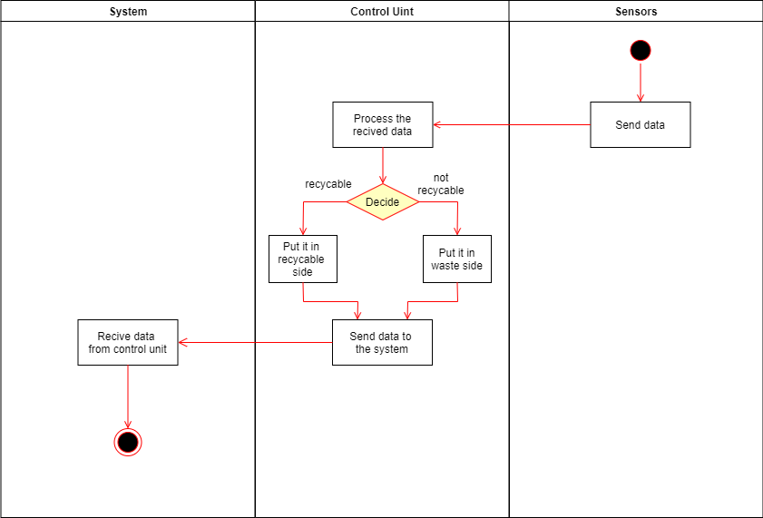

Figure Distinguish and separate material Activity Diagram

### Calculate the points.

In this Activity Diagram, it shows how the flow of events move through the system. First the system will receive the data from the database. Then the system will check if its recyclabe material it will calculate the points, otherwise it will not calculate the points. Then the system will save the points in the database.

Figure Calculate points Activity Diagram

### Update the points.

This activity diagram shows interactions between the user and the system when the user updates the points.

Figure Update Points Activity Diagram

### Redeem rewards.

This activity diagram shows interactions between the user and the system when user Redeem rewards.

Figure Redeem Reward Activity Diagram

### Users edit their profile.

This activity diagram shows interactions between the user and the system when user edit profile.

Figure User edit profile Activity Diagram

### Login.

this diagram shows the login process, the user should input the username and password and then the system should search in the database to find the user if not found the system shown to the user an error message if he/she wants to cancel the process or want to continue and re-input their information again or if the system found the user in the database and verify the password if correct the process complete and if incorrect the system is shown to the user an error message again

Figure Login Activity Diagram

### View friends points.

In this Activity Diagram, it shows how the flow of events move through the system. First the user will navigate to the Friends page, the user can view their friends points from here. Then the user will navigate to the friend page. The system will display the friends points and his/her activities ( Acheivments ). The user can view their friend points and activities.

Figure View friends points Activity Diagram

### Add friends.

In this Activity Diagram, it shows how the flow of events move through the system. First the user will navigate to the friends page. Then the user will navigate to the add friend page. The user can search for their friend. Then the user can add the friend. Then the user will wait for confirmation.

Figure Add friends Activity Diagram

## Sequence Diagrams

### Detect the users account.

this diagram shows the Sequence diagrams describe interactions among classes in terms of an exchange of messages over time in the account detection process,

in the beginning, the actor clicks on detection button on scanning UI and put the phone on the NFC pad and then should send to the control unit to detect the account and return the result

Figure Detect users account Sequence Diagram

### Receive data from sensors.

In this Sequencce Diagram, it shows how the sequence of steps for this function. First the control unit will request to receive the type of material from sensors, the sensors will send the type. Then the control unit will request to receive the wieght of materail from the sensors, the sensors will send the wieght. Then the control unit will send the type and wieght to the code handler. Then the code handler will save them to the database.

Figure Receive data from sensors Sequence Diagram

### Distinguish and separate the material.

this diagram shows the Sequence diagrams describe interactions among classes in terms of an exchange of messages over time to Distinguish and separate the material, initially the sensors should receive the type of material from the control unit and then send the type of data to code handler to handle it and to save this data in the database

Figure Distinguish and separate material Sequence Diagram

### Calculate the points.

In this Sequencce Diagram, it shows how the sequence of steps for this function. First the CalculateHandler will request the type from the database, the database will send the type. Then the CalculateHandler will request the weight from the database, the database will send the wieght. If the type of material is recyclable the CalculateHandler will calculate the points according to the wieght and type. Then it will save the points to the database. If the material is not recyclabe it will display an error message to the user.

Figure Calculate points Sequence Diagram

### Update the points.

This sequence diagram shows interactions between the user and the system when user update the points

Figure Update points Sequence Diagram

### Redeem rewards.

This sequence diagram shows interactions between the user and the system when user select shop list to get redeem rewards

Figure Redeem points Sequence Diagram

### Users edit their profile.

This sequence diagram shows interactions between the user and the system when user edit profile

Figure User edit profile Sequence Diagram

### Login.

This diagram shows the Sequence diagrams describe interactions among classes in terms of an exchange of messages over time to log in process, initially, the user should enter their ID and password to log in UI and then send validate user request to login controller and send the user information to the database to validate it and return the result then create the session to redirect to dashboard

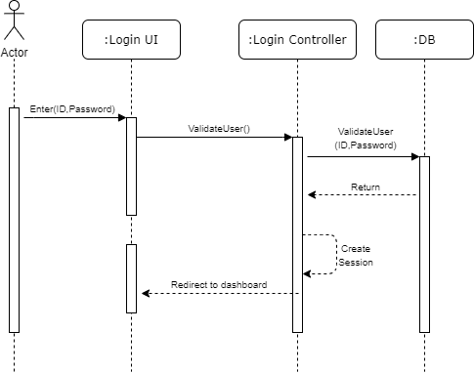

Figure Login Sequence Diagram

### View friends points.

In this Sequencce Diagram, it shows how the sequence of steps for this function. First the User clicks on the firnds page from the Homecreen. Then the HomeScreeen navigates to the FriendsScreen. The FriendsScreen dislays the friends list. Then the user clicks on the friend. Then the FriendsScreen navigate to the FriendScreen. Then the FriendScreen displays the Friend points and activities ( Achievements ). The user can view the points and activities.

Figure View friends points Sequence Diagram

### Add friends.

In this Sequencce Diagram, it shows how the sequence of steps for this function. First the user navigates to the addFriend page from the FriendsScreen. Then the user can search fo a user from the addFriendScreen. Then the addFriendScreen will request the user ID, the database will send the name and points of the user. The AddFriendScreen will display the user. Then the user can add the requested user.

Figure Add friend Sequence Diagram

## Design Class Diagram

In this Design Class Diagram. It shows the objects of the whole system in details and the relationships between them throughout the system.

Figure Design class Diagram

## State Diagrams

### Points

This State Diagram shows the different states of Points and its transitions.

Figure Points Sate Diagram

### Material

State chart diagram of the material in our system, which shows the different state of material which is recycled or not recycled and sense.

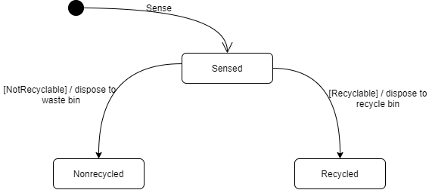

Figure Material State Diagram

### Items

this diagram shows the behaviour of classes in response to external stimuli of items state, initially, the item will be added then you can redeem or we should check the availability of the item available or not, if available you can now redeem the items and if not available you can't redeem.

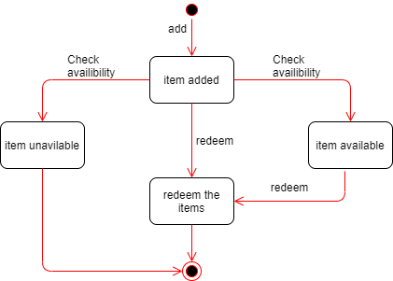

Figure Items State Diagram

### Login

This state diagram shows the different states of the Login and its transitions.

Figure Login State Diagram

## Component Diagram

In this Component Diagram, it shows how different components interacts with each other in our system.

Figure Component Diagram

## Deployment Diagram

In this Deployment Diagram, it shows the physical part of the system and the relations between them from the Mobile ( as a Device ) to the hardware ( as a Device ) and the Database ( as a Server). And it shows the components inside them.

Figure Deployment Diagram

## Input Screens

**Add Friend Screen Login Screen Scan Screen**

User scan to redeem/transact points

**User can Add a friend User Logs in the system

Figure Scan Screen

Figure Login Screen

Figure Add friend Screen

## A screenshot of a cell phone Description automatically generatedA picture containing drawing Description automatically generatedOutput Screens

**Friends Screen**

Users can view their friends list

**Friend Screen**

Users can view their friend points and activities (Achievement).

Figure Friend Screen

Figure Friends List Screen

**Home Screen**

Users can navigate through the system and view their points.

**Leadership**

Users can see the leadership of all users in the system descending

Figure Home Screen

Figure Leadership Screen

Figure Items Screen

Figure Shops Screen

**Popup Screens**

Messages from the system to the user.

**Shops Screen**

Users Can Choose the shop they desire.

**Items Screen**

Users Can Redeem the item they desire.

Figure Popups

# Chapter Four: Implementation and Testing

## Database Mapping (Schema Diagram)

Figure 48 Database Schema Diagram

## Tables Description

### Material Table

Material table consists of type of the material, weight of the material and the date and time of when the material have added as a primary key.

Figure 49 Material Table

### History table

History table consists of id of the user, point_added of the point that been added in a specific date and time of which it’s a foreign key with the date in table material.

Figure 50 Material Table

### Shop Table

This table contains information about each shop who is using the system (shopname , icons ).

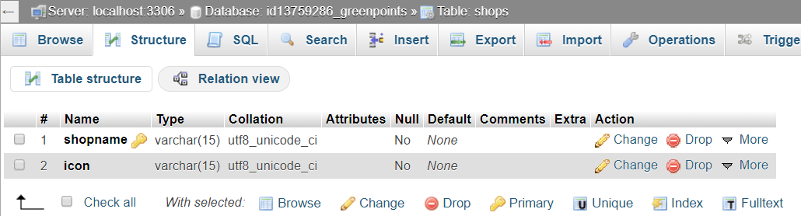

Figure 51 Shop Table

### Items Table

This table contains information about each item who is using the system (shop name, item name, icons, price ).

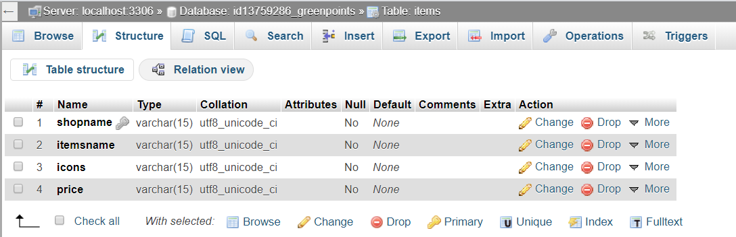

Figure 52Items Table

### Users Table

This table contains just seven columns, ID (Primary Key), Password, Name, Image, Points, Birth Date, Phone Number related to user.

Figure 53 Users Table

### Friends Table

This table contains just two columns first User ID and Second Friend ID.



Figure 54 Friends Table

## Architecture/Technology Description

Figure 55 MVC Architecture

### MVC (Model, View, Controller)

* **Model:** Responsible for storing and receiving data e.g. userID, materialType, materialWieght. Maintenance of state e.g. state of objects. Notification of observers of change in state e.g. methods of object state.
* **View:** Responsible for rendering of model – UI. User interaction. E.g. rendering Screens.
* **Controller:** Responsible for responding to user input. Instructing the model to respond to the user input. E.g. handles of events, objects and sends information to model.

**Why we choose this style?**

We chose this architecture style because we have events and views in our Application. Also, we have different views according to different types of users e.g. Student, Staff. Also, according to different users there are different events and functions that should be handled by the controller and therefore different data that should be stored.

**Components**

* **Model:**
  + We have the handlers that accepts the information from the methods of the controllers and stores it in the database and change the views according the objects.
* **Views:**
  + Screens, UI that the users interact with and sends the data and request the data they want.
* **Controller:**
  + Accepts the input from the views and manipulates the data to the model according to the request of the users.

## Algorithm for major functions

### Login Function

1. onPressed Event -> User press on login button.
2. login() -> wait for fetch the user in the database and retrieve the result.
3. If ID or Password incorrect or empty.
4. Display an error message and ask you to refill information again.
5. else go to next page.

### Redeem Function

1. onPressed Event -> User press option(icon) shops .
2. Display appropriate page.
3. If user is Student.
4. Display shops list of the student.
5. else if a user is staff.
6. Display shop list of the staff.
7. onPressed Event -> user select shop .
8. Display items according to the shop selected
9. onPressed Event -> user selects item
10. if the items are available.
11. Scan and transfer points.
12. else if items not available
13. re-select items.

### Calculate Function

1. onPressed Event -> User selects scan icon.
2. Displays the Scan screen.
3. Wait for material data to be received.
4. Sets the data received in variables and parse it into integers.
5. If the type is more than 0 (recyclable material).
   1. If the weight is less than 500.
   2. Then calculate the points and add it to the current points of the user.
   3. Else show error message that weight exceeded the limit.
6. Else show error message that the material is not recyclable.

## Implementation of main Functions

### Calculate Function

In the calculate function, after pressing the scan button it will call the calculate class which contain the future builder, it will call getMaterial() method then make an instance of object Materials to convert the response from getMaterial() method to this instance (snapshot.data). then the data retrieved from the database it will be parsed into integer and saved in weight and type respectively.

Figure 56 Calculate Class Implementation Code

getMaterial() method in class DataBase-API contains the link to the php page to retrieve the data fro'm the database by method get() from class http then will return materialFromJson method to convert the response from the JSON into Materials object respectively.

Figure 57 getMaterial() method implementation

This get_material php page contains the MySQL commands to retrieve the data from material table in the database and convert it into JSON data.

Figure 58 get_material.php implementation

Materials Class contains materialFromJson method that helps convert the data from JSON to the corresponding variables in the class.

After getting the data from the Database and parsing it into the variables, first it checks for the type of the material if its recyclable or not, if it’s not equals to 0 then it’s recyclable then it will calculate the points according to weight,

Figure 59 Material class implementation

(type 1: paper = 0.00078 JOD/gram, type 2: Aluminum = 0.00086 JOD/gram,

type 3: glass: 0.00078 JOD/gram, and the average is avg = 0.002 JOD/gram

which is quals to 1 point)

so 1 point = 0.002 JOD/gram. then it will call the updateMaterial method to update the points of the user.

Figure 60 implementation of points calculation

### Redeem Function

after press on the shop icon in the home page, will call the class shop screen which contains the Future Builder (), it will call getshops(type) method and send the type of the user (Staff, Student) with it, then make an instance of object shops with the data from method RecurrentObject () , when clicking on any shop will show the items screen.

Figure 61 ShopScreen implementation Code

getshops() method in class Database-API contains the link to the PHP page to retrieve the condition type of user (Staff, Student) and retrieve JSON data and list of shops from the database. then will convert JSON data to class shops respectively.

Figure 62 getShops Method implementation

This get_shops php page contains the MySQL commands to retrieve the data from shops table in the database and convert it into JSON data.

Figure 63 get_shops.php implementation

after select shop from shops list, will call the class items screen which contains the Future Builder (), it will call getitems() method and retrieve data from the database according shop name from shop screen then makes an instance of object items with the data received from the method and display the data in method RecurrentObject (), then will move to page scan.

Figure 64 ItemsScreen implementation Code

getitems() method in class Database-API contains the link to the PHP page to retrieve the condition items According to the shop name and retrieve JSON data from the database. then will convert JSON data to class items respectively.

Figure 65 getitems Method Implementation

This get_items php page contains the MySQL commands to retrieve the data from items table in the database and convert it into JSON data.

Figure 66 get_items.php implementation

## Functional test cases

### Login test cases

|  |  |  |  |  |
| --- | --- | --- | --- | --- |
| Test Case ID | Inputs | Expected Output | Actual Output | Fail/Pass |
| 1 | ID=””, Password=”” | Error Message | Error Message | Fail |
| 2 | ID =”2001”, Password=”20” | Error Message | Error Message | Fail |
| 3 | ID =”2001”, Password=”200” | Logged In | Logged In | Pass |
| 4 | ID =”2”, Password=”200” | Error Message | Error Message | Fail |

Table 17 Login test Cases

### Redeem test cases

|  |  |  |  |  |
| --- | --- | --- | --- | --- |
| Test Case ID | Inputs | Expected Output | Actual Output | Fail/Pass |
| 1 | onPressed Event -> shopname ="Copy center " | List of items From the copy center | Show items from the copy center | Pass |
| 2 | onPressed Event -> shopname ="bookshop" | Show items list for the book shop | List all items from the book shop | Pass |

Table 18 Redeem test Cases

### Calculate test cases

|  |  |  |  |  |
| --- | --- | --- | --- | --- |
| Test Case ID | Inputs | Expected Output | Actual Output | Fail/Pass |
| 1 | Type = 0, weight= 21 | Error message | Error message | Pass |
| 2 | Type = 1, weight = 21 | Points added | Points added | Pass |
| 3 | Type = 1, weight = 1021 | Error message | Points added | Fail |

Table 19 Calculate test Cases

## User Manual

**Login**

Figure 67 Login User Manual

**Home Screen**

Figure 68 Home Screen User Manual

**Friends Screen**

Figure 69 Friends Screen User Manual

**Shops Screen**

Figure 70 Shops Screen User Manual

**Item Screen**

Figure 71 Items Screen User Manual

**Leadership Screen**

This Screen shows all the users and arranged descending from highest score to lowest.

Figure 72 Leader Ship Screen User Manual

**Edit Profile**

Figure 73 Edit Profile User Manual

**Scan Screen**

In this screen the user scan the mobile phone on the pad and redeem or transfer points.

Figure 74 Scan Screen User Manual

# Chapter Five: Conclusion and Future Improvements



## Conclusion

The project was successfully implemented, and as intended, we were unable to perform all functions due to a lack of hardware resources due to Coronavirus (COVID-19) Crisis.

GreenPoints is an easy, fast, and secure mobile application that provides an easy-to-use user interface, allowing users to successfully complete the recycling process through their mobile phone allowing users to track their points they have earned by throwing recyclable materials. The system calculates the points according to the material thrown by the user. Users can redeem points from shops and huts with goods. Also users can view their friends points and profile, leadership where top points earners are placed and can be viewed by the users.

## Future Improvements

One of the future improvements to our project is implementing the hardware components part to help recognize the material and have a unique ID to have synchronized system and work in parallel. Another future improvement to our project is to accept and verify a large number of material types. Also another future improvement is to have limitations on the weight of the material. Adding shops the system is a future improvement. Also letting users claim rewards when reaching specific points. Integrating the system with registration system of the university is also a future improvement. Also due to time shortage in the future the history section in homepage and in friend profile will be dynamic not fixed Finally, we aim to implement our project on a national and global scale.

# References

Aljaradin, M., 2011. PUBLIC AWARENESS AND WILLINGNESS FOR recycle in jordan. *PUBLIC AWARENESS AND WILLINGNESS FOR recycle in jordan ,* Volume 3, p. 4.

Aqeel, A., 2018. *The Engineering Projects TEP.* [Online]   
Available at: https://www.theengineeringprojects.com/2018/06/introduction-to-arduino-uno.html  
[Accessed 11 March 2020].

Arduino, 2020. *Arduino.* [Online]   
Available at: https://www.arduino.cc/en/Guide/Introduction  
[Accessed 11 March 2020].

BUCHANAN, P., 2015. *CISION PrWeb.* [Online]   
Available at: https://www.prweb.com/releases/2015/10/prweb13004398.htm#:~:text=%E2%80%9CGreenbean%20is%20an%20innovative%20loyalty%20program%20that%20rewards%20students%20for%20recycling.&text=TOMRA%20was%20founded%20on%20an,collection%20of%20used%20beverage%20containe  
[Accessed 4 March 2020].

Electronics Projects Focus, 2013. *Electronics Projects Focus.* [Online]   
Available at: https://www.elprocus.com/arduino-sensor-types-and-applications/  
[Accessed 7 March 2020].

EPA, 2017. *United States Enviromental Protection Agency EPA.* [Online]   
Available at: https://www.epa.gov/recycle/recycling-basics  
[Accessed 4 March 2020].

eTechnophiles, 2018. *eTechnophiles.* [Online]   
Available at: https://etechnophiles.com/top-10-arduino-sensors-projects-beginners/  
[Accessed 7 March 2020].

Fawwaz, A. A., 2015. Waste Management in Amman. *Waste Management in Amman,* Volume 4, p. 5.

Gerlat, A., 2015. Tomra Expands Reverse Vending Recycling on Campus.. 1(1), p. 1.

GreenSpot, 2019. *GreenSpot.* [Online]   
Available at: https://greenspotjo.com/  
[Accessed 4 March 2020].

Joe McCarthy, S. ,. E. S., 2016. *Global Citizen.* [Online]   
Available at: https://www.globalcitizen.org/en/content/best-and-worst-recyclers-in-the-world/  
[Accessed 28 November 2020].

Kevin, 2019. *Bringin flutter to the web.* [Online]   
Available at: https://medium.com/flutter/bringing-flutter-to-the-web-904de05f0df0  
[Accessed 7 March 2020].

khashashneh, D. a., 2002. Solid Waste Management: The Jordanian Experience. *Solid Waste Management: The Jordanian Experience,* Volume 20, p. 50.

Kissam, B., 2019. *College Advice Blog.* [Online]   
Available at: https://www.thecoachkshow.com/college-students-and-coffee/  
[Accessed 7 March 2020].

Plastic Oceans, 2020. *Plastic Oceans.* [Online]   
Available at: https://plasticoceans.org/the-facts/  
[Accessed 7 March 2020].

Rinkesh, 2020. *Conserve Energy Future.* [Online]   
Available at: https://www.conserve-energy-future.com/why-is-recycling-important.php  
[Accessed 3 March 2010].

Rouse, M., 2006. *TechTarget.* [Online]   
Available at: https://searchsqlserver.techtarget.com/definition/SQL-Server  
[Accessed 7 March 2020].

SparkFun, 2017. *SparkFun.* [Online]   
Available at: https://www.sparkfun.com/products/13879  
[Accessed 11 March 2020].

UNDP in Jordan, 2017. *UNDP in Jordan.* [Online]   
Available at: https://www.jo.undp.org/content/jordan/en/home/ourwork/our_stories/new-municipal-solid-waste-recovery-and-recycling-contract-improv.html  
[Accessed 8 march 2020].

Wenjing, Z., 2019. The Situation with College Express Packaging Waste and Recycling Recommendations—Taking the Graduate School of the Chinese Academy of Social Sciences as an Example. *Journal of Resources and Ecology,* 10(5), pp. 1-8.

# Appendixes

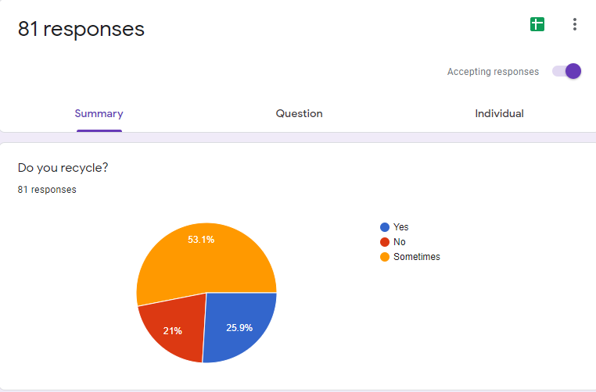

Appendix A - Figure Recycle Group

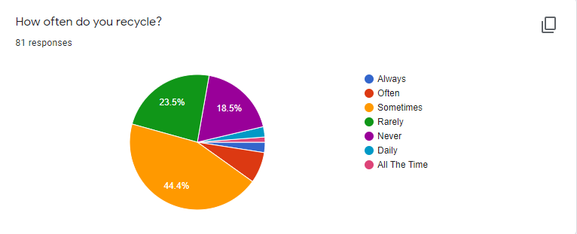

Appendix A - Figure Recycle frequency Group

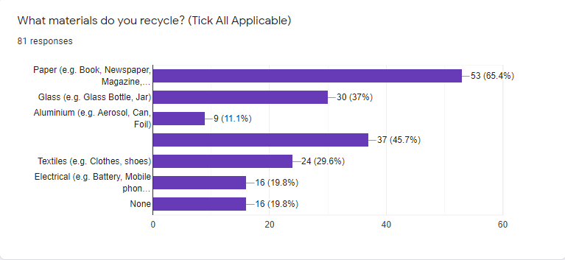

Appendix A - Figure Recycling material Group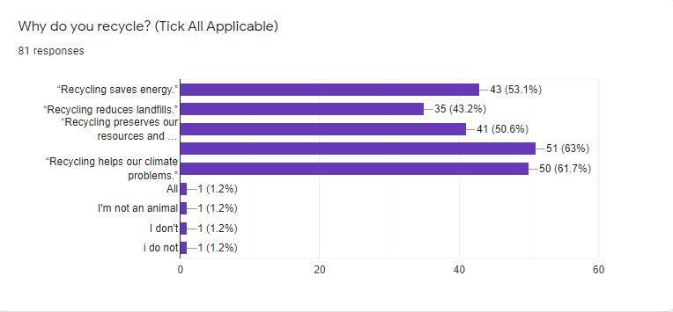

Appendix A - Figure Why Recycling ? 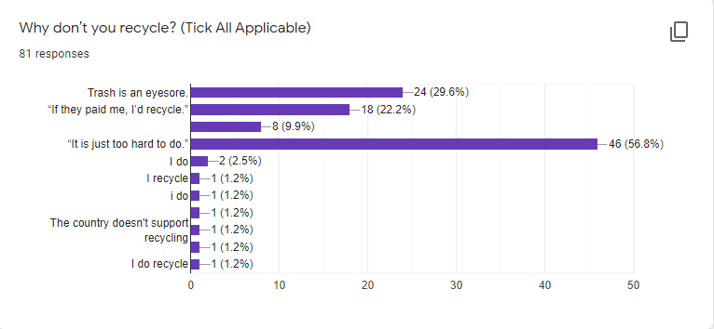

Appendix A - Figure Why not Recycling?

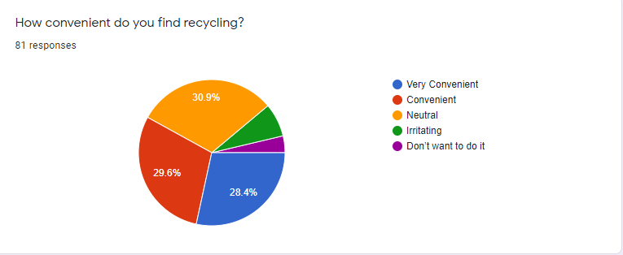

Appendix A - Figure How Convenient?

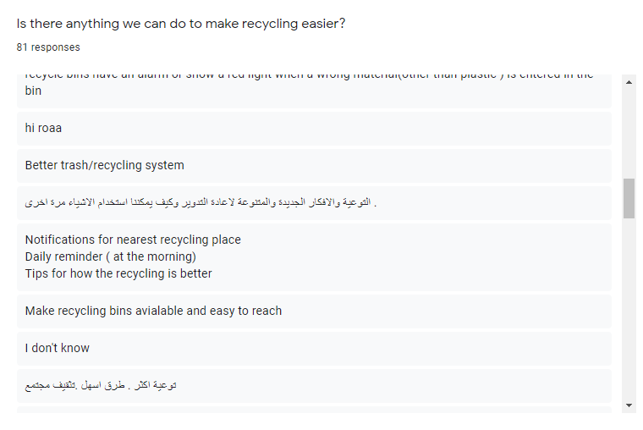

Appendix A - Figure Recommendation for easier recycling

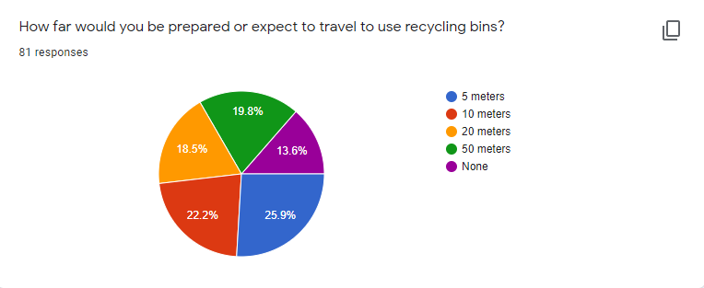

Appendix A - Figure Distance group

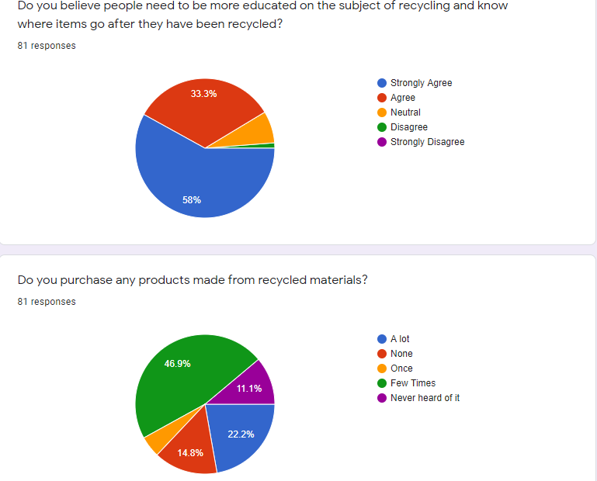

Appendix A - Figure relativity to education and consuming recycled material Group